Integration Doc Requirements

Instructions
Please complete the following steps and submit completed documentation and signed forms to integrator-docs@procore.com. You must satisfy these requirements BEFORE your integration can be published and made available on Procore’s App Marketplace (http://marketplace.procore.com). Please see the Developer Success Roadmap for more information.

Required Steps
- Create end user documentation. Use the document templates below to provide sufficient product documentation about your integration.
  - Tutorials
  - Troubleshooting/FAQs
  - Permissions Table
  - Release Notes
  - Support
- When finished, email the completed documentation to integrator-docs@procore.com.

Overview
Procore’s Support site serves as the central repository or knowledge base for all products and features related to the Procore construction management platform (https://app.procore.com/) including integrations and custom applications developed by third party integrators. All Procore end users are trained and encouraged to leverage Procore’s Support site for all support related product documentation including tutorials, FAQs, release notes, etc.

You may also publish your product documentation to your company’s own website or support knowledge base, but it must be at a minimum available on the Procore Support website. (Note: If you already created support documentation on your company’s own website, a hyperlink to those web pages is sufficient.)

Example: Integrator Homepage
Each integrator will have its own homepage or landing page on Procore’s Support site. (e.g. https://support.procore.com/integrations/acme)

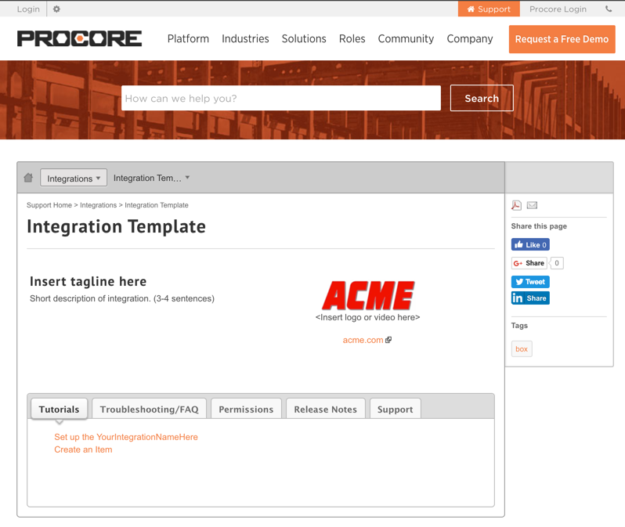
Example of an Integrator’s homepage
(e.g. https://support.procore.com/integrations/acme)

Your homepage will include the following key sections/tabs.
- Tutorials - How-to guides for working with the integration
  - Installation/Setup Guide (Required)
  - Create____
  - Edit____
- Troubleshooting/FAQs - Answers to common support related issues
- Permissions - Breakdown of which permissions (e.g. Read-only, Standard, Admin) are required to perform common tasks such as creating, editing, or deleting an object
- Release Notes - Historical record of new features and recent changes
- Support - Customer support information

TEMPLATE: HOMEPAGE
* Denotes required sections. Follow examples on https://support.procore.com. (View Example)

Your Company Name: ACME

Tagline*:
Please keep the length short and concise. (e.g. Sync Project Data in Real-time)
- Enter tagline here

Description*:
Provide a short description of your integration (2-4 sentences).
- Enter description here

View the Features:
Highlight 3-5 key features.
- Enter list of features here

Logo:
Provide the preferred logo.
- Enter hyperlink to logo (.jpg, .png) -OR- email file to integrator-docs@procore.com.

TEMPLATE: TUTORIAL
* Denotes required sections. Follow examples on https://support.procore.com. (View Example)

Page Title: Set Up ___ Integration; Create a ___

Objective*
To set up the ____ integration on a Procore account.

Background
When ____ occurs on the job site and you need to…
The ___ integration will help you...

Things to Consider*
- Required User Permission: 'Standard' or 'Admin' on the project's Budget tool.
- Add insights and prerequisites

Steps*
- Navigate to the Procore account’s Admin tool at the Company level.
- Click the Create button.
- Enter ‘Value Example’ for the Title field.
- Select ‘Item Name’ from the dropdown menu.

TEMPLATE: FAQ
(View Example)

- Can I ____?
  - Add answer here
- Which fields are ____?
  - Add answer here

TEMPLATE: Permissions
Use the table below to list the common tasks that will be performed as well as the required user permissions that apply. In some cases, the permissions are related to an existing tool/tab in Procore (e.g. Documents, Schedule, etc.). In other cases, it applies to a custom tool/tab that matches the integrations name. (e.g. Botlink, Assemble, etc.)

* Denotes required sections. Follow examples on https://support.procore.com. (View Example)

Tool*: Documents

Task | None | Read-only | Standard | Admin
Set up IntegrationName |  |  |  | X
Create Object |  |  | X | X
Edit Object |  |  | X | X
Delete Object |  |  |  | X

TEMPLATE: Release Notes
Each integration will have a designated Release Notes section where you can highlight new features, general changes, and bug fixes related to newer versions of your integration. You can choose to create a list categorized by release date (shown below) or version number (e.g. v1.3.15).

December 15, 2016
- Title
Description
- Title
Description

March 22, 2016
- Title
Description
- Title
Description

TEMPLATE: Support

End Users
Q: How should your end users contact you in order to receive customer support for your integration?
A: <<Please list all that apply>>
- Phone: +1 866-123-4567
- Email: support@example.com
- Web: http://support.example.com/support-forum

Q: How would you like to receive customer feedback?
A: <<Please list all that apply>>
- Report an Issue: http://support.example.com/report-a-bug
- Leave Feedback: http://support.example.com/feedback-form

Procore Support
Procore’s own Support team will likely receive support related questions about your integration via email, phone, or live chat.

Q: How would you like us to answer those types of questions?
A: Please forward all support related questions to _______. Tell them to call ____.

Q: If an internal Procore employee discovers a problem/issue related to your integration, how would you like Procore to notify your team?
A: Please call _______ or email ______.

